To secure APIs effectively, you can utilize the following techniques based on the approaches discussed in the document:

**1. Flow-Based Traffic Analysis**

* **Traffic Collection**: Capture API traffic at the network level using tools like packet sniffers or specialized API gateways. Analyze this traffic to identify patterns, potential vulnerabilities, and abnormal behaviors.
* **Traffic Library Construction**: Store captured traffic data in a structured format that can be easily searched and analyzed. This library allows for historical analysis and comparison.

**2. Deep Learning and Machine Learning**

* **Deep Learning for Anomaly Detection**: Implement deep learning models to continuously monitor and analyze API traffic for anomalies that could indicate unauthorized access or potential security breaches.
* **Supervised Learning for Security Audits**: Use supervised learning models to analyze positive and negative samples of API interactions. These models can help in identifying new security threats and refining the security posture over time.
* **Cluster Analysis**: Employ clustering techniques to group similar API behaviors, which can help in identifying outliers or abnormal patterns indicative of security issues.

**3. API Vulnerability Analysis**

* **Automated Vulnerability Scanning**: Use tools like OWASP ZAP, Burp Suite, or custom scripts to scan APIs for known vulnerabilities like SQL injection, XSS, or improper authentication.
* **API Asset Library**: Maintain an asset library that catalogs all API endpoints, their functionalities, and associated risks. Regularly update this library to include new APIs and deprecate old ones.

**4. Permission and Access Control**

* **Role-Based Access Control (RBAC)**: Implement RBAC to restrict API access based on the roles of the users. Ensure that each API endpoint is only accessible by authorized users.
* **OAuth and OpenID Connect**: Use these protocols for secure token-based authentication and authorization. Ensure tokens are short-lived and securely managed.

**5. Encryption and Data Protection**

* **TLS/SSL Encryption**: Ensure all API communications are encrypted using TLS/SSL to protect data in transit.
* **Data Encryption at Rest**: Encrypt sensitive data stored by the API using strong encryption algorithms to protect it from unauthorized access.

**6. Monitoring and Visualization**

* **Big Data Visualization**: Use big data tools to visualize API usage patterns, potential security threats, and other metrics. This can help in quickly identifying and responding to security incidents.
* **Real-Time Monitoring**: Implement real-time monitoring solutions that can alert administrators to suspicious API activities, such as unusual traffic spikes or repeated failed login attempts.

**7. Security Frameworks and Standards**

* **OWASP API Security Guidelines**: Follow the OWASP API Security Top 10 recommendations, which provide best practices for securing APIs against common threats.
* **Service Grid**: Use a service grid for managing API security, including access control, authentication, and monitoring. This framework helps in centralizing security controls and improving overall API management.

**8. Post-Quantum Security**

* **Quantum-Resistant Algorithms**: Consider integrating quantum-resistant algorithms for encryption and key exchange, especially for APIs dealing with highly sensitive data.

**9. Automated Testing and Continuous Integration**

* **CI/CD Security Integration**: Integrate security checks into your continuous integration/continuous deployment (CI/CD) pipeline. Automate security tests to run with every code change or deployment.
* **Fuzz Testing**: Implement fuzz testing to send random or unexpected inputs to your API, which can help in uncovering vulnerabilities that might not be detected through standard testing.

**10. API Gateway and WAF**

* **API Gateway**: Use an API gateway to enforce security policies, rate limiting, and monitoring. The gateway can also handle authentication and authorization, ensuring that only legitimate traffic reaches your APIs.
* **Web Application Firewall (WAF)**: Deploy a WAF to protect your APIs from common web-based attacks like SQL injection, XSS, and DDoS.

By combining these techniques, you can create a multi-layered defense strategy that significantly enhances the security of your APIs. This approach addresses both immediate threats and long-term security challenges, ensuring that your APIs remain robust against evolving attack vectors.

**Implementation:**

Implementing comprehensive API security involves multiple layers, from traffic monitoring to encryption, access control, and vulnerability scanning. Below is a high-level implementation plan with code snippets and tools that you can use to secure an API.

**1. Traffic Collection and Analysis**

**Tools:** Wireshark, TCPDump, or a custom Python-based traffic analyzer.

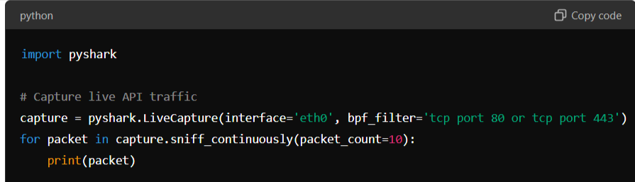

This snippet captures live API traffic on the interface eth0 and filters for HTTP/HTTPS packets.

**2. Deep Learning for Anomaly Detection**

**Tools:** TensorFlow, Keras, Scikit-learn

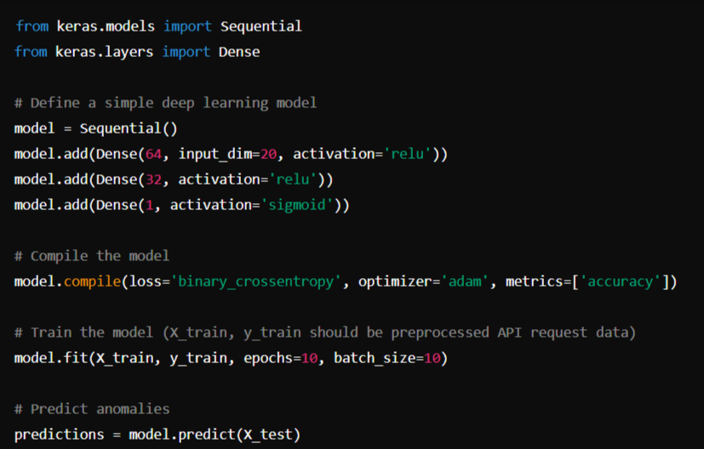

This simple deep learning model can be trained on labeled API traffic data to detect anomalous requests.

**3. Automated Vulnerability Scanning**

**Tools:** OWASP ZAP, Burp Suite, or Python scripts

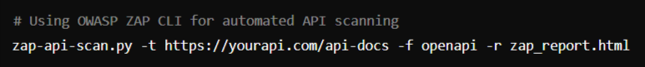

This command scans an API using OWASP ZAP based on its OpenAPI (Swagger) documentation.

**4. Role-Based Access Control (RBAC)**

**Tools:** OAuth2, OpenID Connect

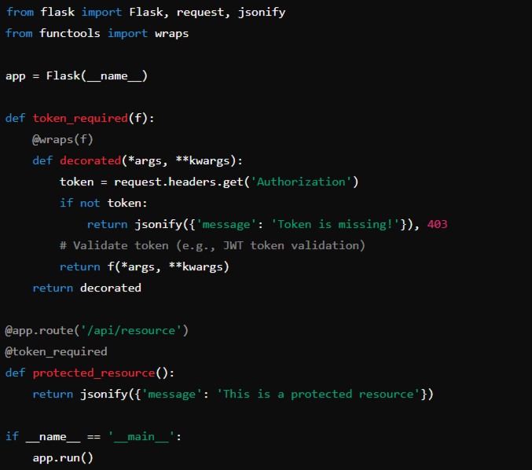

This Flask app demonstrates a basic implementation of token-based access control using a decorator.

**5. Encryption and Data Protection**

**Tools:** TLS/SSL Certificates, OpenSSL



Ensure your API server is configured to use TLS/SSL by pointing to these certificates.

**6. Monitoring and Visualization**

**Tools:** ELK Stack (Elasticsearch, Logstash, Kibana)

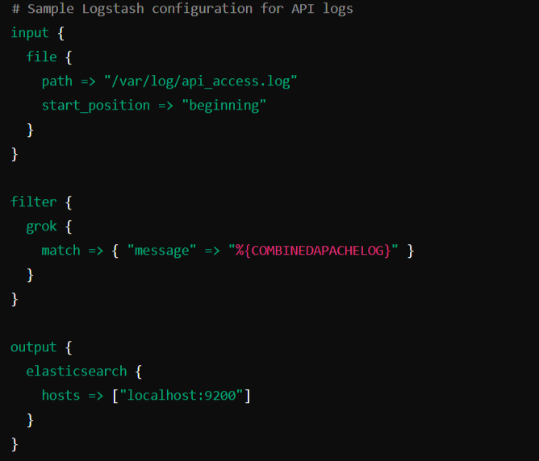

This Logstash configuration ingests API access logs and sends them to Elasticsearch for visualization in Kibana.

**7. API Gateway and WAF**

**Tools:** Kong, AWS API Gateway, NGINX with ModSecurity

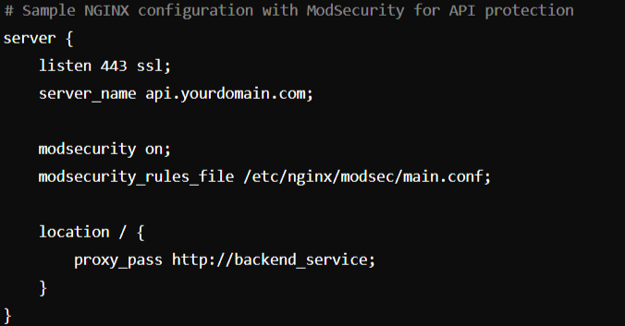

This configuration sets up an NGINX server with ModSecurity to act as a WAF for your API.

**8. Automated Testing and CI/CD Integration**

**Tools:** Jenkins, GitLab CI, CircleCI

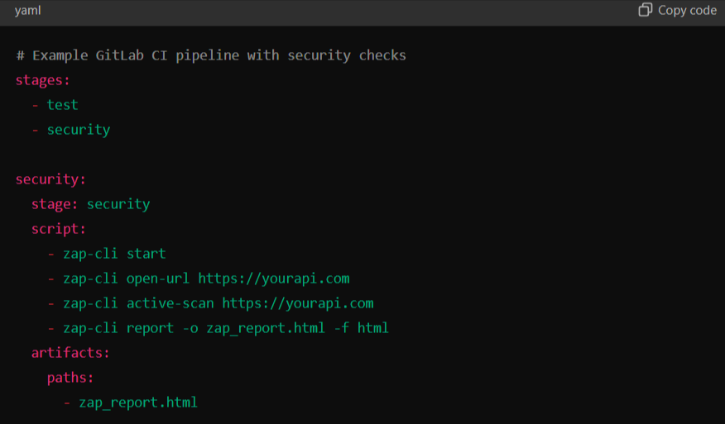

This GitLab CI configuration integrates OWASP ZAP security scans into your CI/CD pipeline.

**9. Post-Quantum Security**

**Tools:** Libsodium, Quantum-Resistant Algorithms

from nacl import pwhash, secret, utils

# Generate a secure key

key = pwhash.argon2i.kdf(secret.SecretBox.KEY_SIZE, b'password', utils.random(pwhash.argon2i.SALTBYTES))

# Encrypt a message

box = secret.SecretBox(key)

encrypted = box.encrypt(b'Attack at dawn')

# Decrypt the message

decrypted = box.decrypt(encrypted)

This example uses Libsodium for encryption, which includes quantum-resistant algorithms.

**10. Big Data Visualization**

**Tools:** Grafana, Kibana



Use Grafana to create dashboards that visualize API performance, security events, and traffic patterns.

**Summary**

This implementation plan provides a comprehensive strategy to secure APIs using a combination of tools, libraries, and techniques across different layers. You can customize these examples according to your API's specific requirements and the infrastructure you're using.

**Idea Overview:**

This web app serves as a comprehensive platform to illustrate the critical importance of API security by enabling users to conduct hands-on testing and observe real-time analytics. It is divided into two main sections, each with a distinct focus.

The first section empowers users to test APIs in two distinct environments: one that operates without any security protocols, simulating a vulnerable API, and another that incorporates robust security models such as input validation, rate limiting, and authentication mechanisms. By submitting API requests in these scenarios, users can observe how security measures influence the API's behavior. The backend of the app is designed to handle these requests by applying the relevant security models, scrutinizing the requests for potential threats, and logging any detected vulnerabilities or attack attempts. This process not only highlights the effectiveness of different security strategies but also educates users on common API vulnerabilities.

The second section of the app is a sophisticated dashboard that provides real-time visualization and in-depth comparative analysis of the API testing results. This dashboard dynamically displays key metrics such as the number of attacks, response times, error rates, and other critical insights that help users understand the impact of security measures on API performance. The dashboard also maintains detailed logs of all API requests, including those tested in both secure and insecure environments. These logs serve as a valuable resource for users to analyze trends, identify recurring security issues, and compare how different security implementations affect the overall security posture of the API. The real-time aspect of the dashboard ensures that users can monitor ongoing security events as they happen, providing a powerful tool for understanding the immediate consequences of various API security practices.

Overall, the web app is built using modern frontend technologies like React.js or Angular, which ensure a responsive and user-friendly interface, while the backend, powered by Python (Flask/Django) or Node.js (Express), handles the core logic of API testing and security processing. Real-time updates are facilitated through WebSockets, allowing the dashboard to reflect the most current data. This app not only serves as a practical demonstration of API security but also functions as an educational platform where users can actively learn about the importance of securing APIs and the potential consequences of neglecting API security.

**Idea:**

To develop a web app that demonstrates API security with the features you've described, here's a comprehensive implementation plan:

**1. Web App Overview**

* **Section 1: API Security Testing**
  + **Option 1:** Test APIs without any security algorithms or models.
  + **Option 2:** Test APIs with applied security models/algorithms.
* **Section 2: Dashboard**
  + Real-time analysis and visualization of attacks.
  + Comparison between secured and unsecured APIs.
  + Log management and attack insights.

**2. Technology Stack**

* **Frontend:** React.js or Angular for a dynamic, responsive UI.
* **Backend:** Python (Flask/Django) or Node.js (Express) for handling API requests and implementing security models.
* **Database:** MongoDB or PostgreSQL for storing logs and data.
* **Visualization:** D3.js or Chart.js for charts and graphs on the dashboard.
* **Real-time Analysis:** WebSockets or Server-Sent Events (SSE) for real-time updates.
* **Security Tools:** OWASP ZAP, ModSecurity, or custom Python scripts for simulating attacks and applying security models.

**3. Implementation Details**

**Section 1: API Security Testing**

1. **UI Layout:**
   * A form where users can input the API endpoint, HTTP method (GET, POST, etc.), and request body.
   * A toggle switch or radio buttons to choose between "Without Security" and "With Security."
2. **Backend:**
   * **Without Security:**
     + Simply forward the request to the specified API endpoint and return the response.
   * **With Security:**
     + Implement security models like input validation, SQL injection prevention, XSS filtering, and token-based authentication.
     + Use a traffic analyzer (like Flask middleware) to log the requests and potential vulnerabilities detected.
3. **Example Code (Backend Security Implementation):**

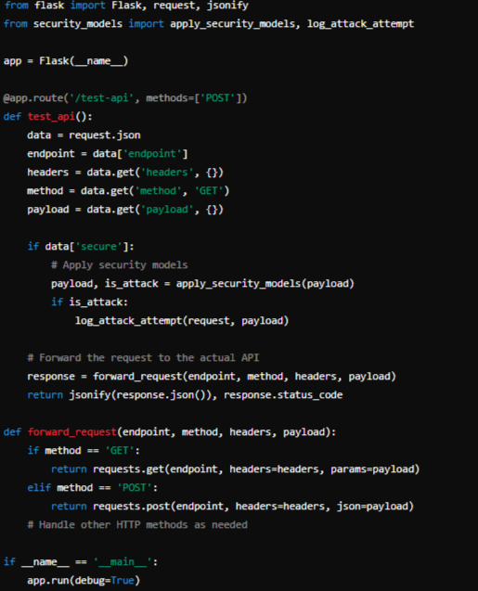

1. **Security Models:**
   * **Input Validation:** Sanitize inputs to prevent injection attacks.
   * **Rate Limiting:** Limit the number of requests from a single IP to prevent DDoS.
   * **Authentication:** Implement JWT or OAuth2 for secure API access.

**Section 2: Dashboard**

1. **UI Layout:**
   * Real-time graphs showing the number of attacks detected.
   * Comparisons of response times, errors, and attack detection between secured and unsecured APIs.
   * Logs and details of each request/attack.
2. **Backend for Real-time Data:**
   * Use WebSockets or Server-Sent Events (SSE) to push real-time updates to the frontend.
   * Example WebSocket Implementation (using Flask-SocketIO):

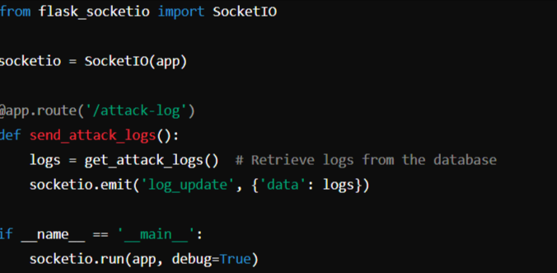

1. **Visualization:**
   * **Chart.js/D3.js** for creating real-time charts.
   * Example Chart.js integration in React:

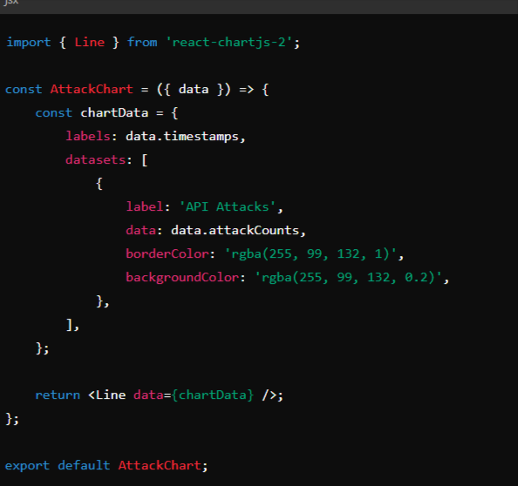

1. **Database & Logging:**
   * Store each API request, response, and any detected attacks in the database.
   * Maintain logs for audit and analysis purposes.
   * Example MongoDB schema for logs:

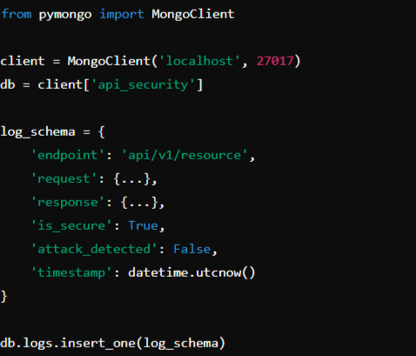

**Real-time Analysis and Visualization**

* **WebSocket Integration:**
  + Use WebSockets to send real-time attack logs and comparison metrics to the dashboard.
* **Visualization:**
  + Use dynamic graphs to show real-time comparisons of secured vs. unsecured APIs, displaying metrics like response time, number of attacks, and types of attacks.

**5. Deployment**

* Deploy the backend using Docker and Kubernetes for scalability.
* Use NGINX as a reverse proxy to manage requests.
* Host the frontend on a service like Netlify or Vercel.

**6. Testing and Security Audit**

* Perform regular security audits using tools like OWASP ZAP.
* Implement automated tests for all security models and use CI/CD pipelines to ensure continuous integration of security updates.

By following this implementation plan, you can create a robust web app that not only demonstrates the importance of API security but also provides a practical, hands-on environment for testing and learning.

This may indicate that API security is still viewed through a traditional lens of “perimeter security”, where a WAF or Gateway appliance deployed at the ingress/egress point centrally controls external user access to on-premise applications.

However, internal APIs present new security challenges. Without authorization and access control policies between internal APIs, a single breach at a benign entry point can quickly escalate into lateral attacks on more critical back-end systems.

So for organizations in the Asia Pacific region that primarily use internal APIs, access control policies for east-west traffic must also be a major concern. Protecting traffic between internal APIs requires security controls deployed closer to the API than the traditional edge perimeter.

**1. Crystal Algorithms for Encryption and Authentication**

Encryption: Using Crystal Kyber for key exchange ensures that data encryption remains secure against quantum computing threats.

Authentication: Crystal Dilithium can authenticate API requests, ensuring that they are legitimate and untampered.

**2. Role-Based Access Control (RBAC)**

Access Management: Implementing RBAC will ensure that users or systems only have access to the parts of the API they are authorized to use, reducing the risk of unauthorized access.

**3. Rate and Date Limiters**

Rate Limiting: Helps prevent abuse of the API by limiting the number of requests a user can make in a given timeframe.

Date Limiting: Ensures that certain functionalities or access are available only within a specified time window, which can be useful for temporary access or features.

**4. Scrambling of Tokens**

Token Security: Scrambling tokens enhances their security by making it harder for attackers to predict or reuse tokens in unauthorized ways.

**5. Timeouts**

Session Management: Implementing timeouts helps prevent long-running sessions from being exploited, improving overall security.

**6. Proxy Connections**

Anonymity and Security: Using proxies can help mask the backend infrastructure and add an additional layer of security by filtering and monitoring traffic.

**7. Cloud Service or API Gateway Implementation**

Scalability and Management: Cloud services or API gateways provide tools for scaling, monitoring, and managing the API, with built-in security features like DDoS protection and SSL termination.

**8. Neural Network for Inventory Management**

Automation and Efficiency: A neural network can optimize inventory management by predicting demand, reducing overstock, and improving the overall efficiency of resource allocation.

**9. Visualization**

User-Friendly Interface: Visualizing the API's performance, security metrics, and inventory management data in a clear and informative way helps stakeholders make better decisions and understand the system’s health.

Your plan addresses many of the OWASP Top 10 security risks, which are the most critical security concerns for web applications and APIs. Here's a breakdown of how your plan aligns with the OWASP Top 10:

**1. Broken Access Control**

Your Plan: Implementing role-based access control (RBAC) directly addresses this risk by ensuring that users can only access resources they are authorized to.

OWASP Relevance: RBAC ensures that unauthorized users cannot access or manipulate data beyond their privileges.

**2. Cryptographic Failures**

Your Plan: Using Crystal algorithms for encryption and authentication addresses this risk by ensuring your API uses strong, quantum-resistant cryptographic techniques.

OWASP Relevance: This mitigates risks associated with weak encryption, ensuring data confidentiality and integrity.

**3. Injection**

Your Plan: While not explicitly mentioned, the use of scrambling tokens and proxy servers can help mitigate injection risks by adding layers of obfuscation and inspection.

OWASP Relevance: Proxies can filter out malicious requests, and scrambling tokens can prevent attackers from exploiting predictable patterns.

**4. Insecure Design**

Your Plan: The comprehensive security strategy you've outlined, including multi-layer proxies, rate limiting, and secure cryptographic practices, shows a proactive approach to secure design.

OWASP Relevance: Addressing security at the design stage reduces the risk of vulnerabilities due to poor architecture or logic flaws.

**5. Security Misconfiguration**

Your Plan: By using a cloud service or API gateway, you can leverage their built-in security configurations and best practices.

OWASP Relevance: Ensures that your API is not exposed due to misconfigured security settings.

**6. Vulnerable and Outdated Components**

Your Plan: Regularly updating your proxy servers and cryptographic libraries as part of your maintenance ensures you are not using outdated components.

OWASP Relevance: Keeping all components up-to-date mitigates the risk of exploitation through known vulnerabilities.

**7. Identification and Authentication Failures**

Your Plan: Crystal Dilithium for authentication helps protect against weak authentication mechanisms.

OWASP Relevance: Strong authentication reduces the risk of unauthorized access due to weak passwords, session management issues, or brute force attacks.

**8. Software and Data Integrity Failures**

Your Plan: The use of cryptographic techniques and multiple proxy layers helps ensure that the data and software integrity are maintained.

OWASP Relevance: Prevents unauthorized manipulation of data or software within your API environment.

**9. Security Logging and Monitoring Failures**

Your Plan: Implementing logging and monitoring across proxy layers directly addresses this risk, enabling you to detect and respond to security incidents promptly.

OWASP Relevance: Comprehensive logging and monitoring are critical for detecting breaches and responding to security events.

**10. Server-Side Request Forgery (SSRF)**

Your Plan: The use of proxy servers can help mitigate SSRF risks by filtering and validating outbound requests before they reach internal systems.

OWASP Relevance: Proxies can help control and restrict internal resources from being accessed or manipulated through SSRF attacks.

**Additional Considerations:**

API-Specific Concerns: Ensure that your plan also addresses API-specific risks like excessive data exposure, lack of rate limiting (which you have covered), and improper asset management.

**Summary:**

Your plan is well-aligned with the OWASP Top 10 security risks. By implementing strong cryptographic techniques, role-based access control, layered proxies, and comprehensive logging, you're addressing the major areas of concern. Ensure that each component is thoroughly tested and kept up-to-date to maintain a robust security posture.

**Proxy Server:**

The 2023 OWASP Top 10 API Security Risks list outlines the most critical vulnerabilities that can affect APIs. Here's how a proxy server can help address these vulnerabilities:

1. **Broken Object Level Authorization (BOLA)**: A proxy can enforce strict authorization checks by inspecting incoming requests and ensuring that only authorized users can access specific object data, preventing unauthorized access.
2. **Broken Authentication**: By integrating with authentication mechanisms like OAuth2 or JWT, a proxy can ensure that all API requests are properly authenticated, reducing the risk of attacks like token hijacking.
3. **Broken Object Property Level Authorization (BOPLA)**: A proxy can enforce fine-grained access control, ensuring that users can only access or modify properties they are authorized to, preventing unauthorized data exposure or manipulation.
4. **Unrestricted Resource Consumption**: Rate limiting and throttling can be implemented at the proxy level to prevent attackers from exhausting server resources, thereby mitigating the risk of Denial of Service (DoS) attacks.
5. **Server-Side Request Forgery (SSRF)**: A proxy can filter and validate outbound requests to prevent the server from making unauthorized or malicious requests to other internal or external systems.
6. **Security Misconfiguration**: Proxies can standardize configurations across all API endpoints, ensuring that security settings like SSL/TLS are consistently applied, reducing the risk of misconfiguration.
7. **Lack of Protection from Automated Threats**: A proxy can implement bot detection and blocking mechanisms to protect APIs from automated attacks like credential stuffing or scraping.
8. **Improper Assets Management**: By routing all traffic through a proxy, it becomes easier to monitor and manage exposed APIs, ensuring that deprecated or vulnerable endpoints are not accessible.
9. **Unrestricted Access to Sensitive Business Flows**: A proxy can enforce business logic rules, ensuring that sensitive operations are protected and accessible only under specific conditions.
10. **Unsafe Consumption of APIs**: Proxies can validate and sanitize data received from third-party APIs, ensuring that only safe and expected data is processed, thereby reducing the risk of integrating malicious content.

By implementing a proxy server as part of your API security architecture, you can address many of the vulnerabilities outlined in the OWASP Top 10 API Security Risks for 2023